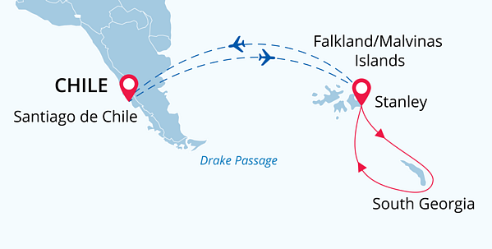

Falklands & South Georgia
South Georgia Through the Camera Lens
19 Oct - 02 Nov 2024
15 days
Embarkation: Stanley (Falkland Islands)
Disembarkation: Stanley (Falkland Islands)
M/v Sea Spirit
Activities:

Itinerary
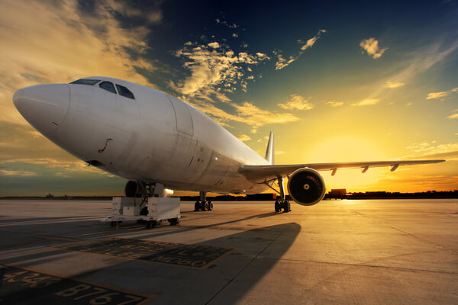Day 0 (Oct 18): Arrival to Santiago
We suggest that our tourists arrive in Santiago de Chile a day earlier to have a good rest after a long flight before our Subantarctic adventures begin. A pre-cruise night is not included in the price of the itinerary, but we highly recommend the Holiday Inn Hotel due to its most favorable location right in the airport terminal.
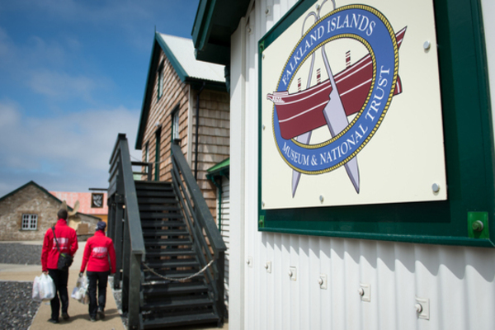Day 1 (Oct 19): Flight to Stanley, Falkland Islands. Embarkation
Our expedition will start in the early morning in the airport of Santiago de Chile where we will take a transfer flight to the Falkland Islands. Welcome to Stanley, the capital of the Falkland Islands and the starting point of our cruise. Embarktion in the Falklands helps us to minimize our days at sea, which means more time for landings and photography! In the afternoon, you will be transferred to the pier where we will warmly welcome you aboard our expedition ship M/V Sea Spirit. Get comfortable in your home away from home for the extraordinary adventure to come.
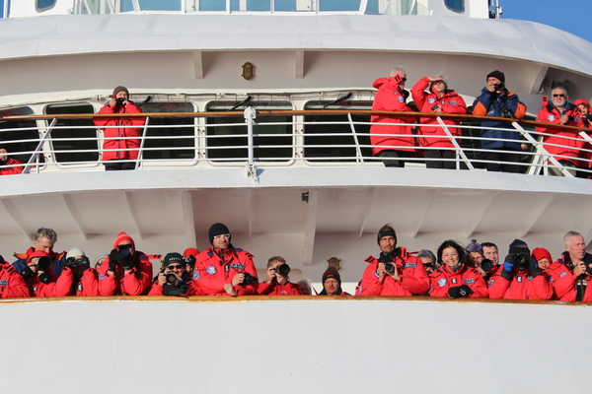Day 2-3 (Oct 20-21): Aboard M/V Sea Spirit
As we sail east towards South Georgia, we will be able to witness incredible wildlife. We will also cross the Antarctic Convergence, the biological boundary of the Southern Ocean.
Don’t lose your time aboard! Attend the most interesting briefings and lectures from our expert staff and prepare yourself for the arrival in South Georgia.
This cruise was designed for amateur photographers of all skill levels, so use this chance to make new friends, exchange your photo experience and attend our photography master classes. Discussing ISO and exposure is always better in our cozy bar, restaurant, or lounge.
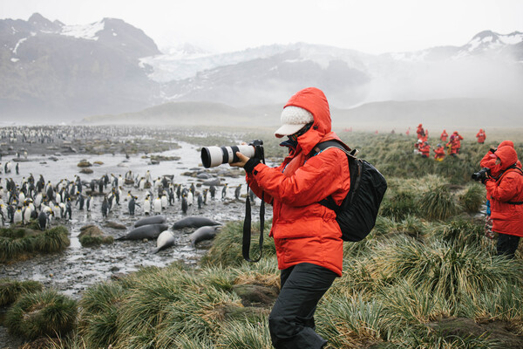Day 4-12 (Oct 22-30): Exploring South Georgia
South Georgia is the best place on Earth for wildlife and landscape photographers. We will take you to great locations for the best light. The archipelago is the home to hundreds of thousands of king penguins, which makes South Georgia the best spot to photograph these wonderful creatures. Our plan is to visit the most picturesque sights such as Gold Harbour, Cooper Bay, Drygalski Fjord and other great places. For example, the beaches such as those at Salisbury Plain and St. Andrews Bay, where over 100,000 elephant seals and three million fur seals jostle for space among innumerable penguins.
The bountiful waters surrounding South Georgia are also inhabited by an increasing number of whales. The historical whaling station of Grytviken is now home to the excellent South Georgia Museum managed by the South Georgia Heritage Trust. This is also the final resting place of Ernest Shackleton, the legendary polar explorer.
However, our route and exploration opportunities in South Georgia are heavily dependent on the weather conditions we encounter. Our experienced captain and expedition leader decide the itinerary and continually adjust plans as conditions and opportunities warrant. You can be sure that the best possible advantage will be taken of the circumstances presented to us by Nature in this wild and remote corner of the world. We take every safe opportunity to go ashore in this amazing place and take the best wildlife photos.
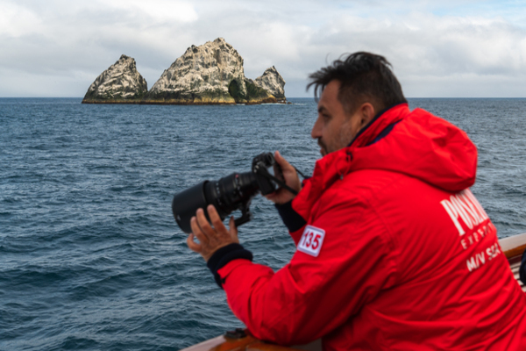Day 13-14 (Oct 31- Nov 1): Back to the Falkland Islands
It is time to head back toward the Falkland Islands. However, our adventures are not over yet. We will pass the remote, seabird-covered pinnacles known as Shag Rocks on the way (get your cameras ready!) There is also time for festivities such as the Captain’s Farewell Cocktail and the end-of-voyage slide show. We will share our impressions, review all the great photos we’ve taken and enjoy a friendly atmosphere of like-minded fellow travellers.
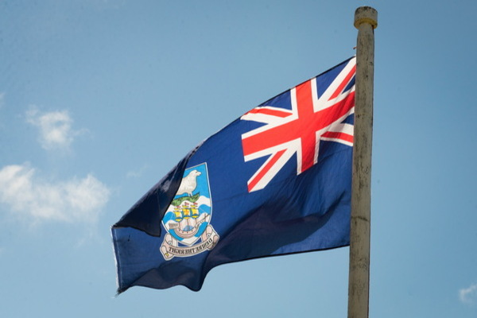Day 15 (Nov 2): Disembarkation in Stanley. Flight to Santiago
Our adventure finishes in Port Stanley. We disembark after breakfast and provide transfer to the airport. Have a safe flight to Santiago. We recommend you to explore the wonderful capital of Chile and spend more time here. Now when the first emotions have subsided you will have time to look back to your unforgettable Subantarctic experience and maybe to make plans for your next polar adventure?

Special guest
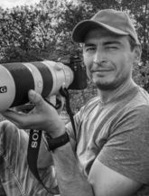Dmitry Kokh
Photographer
Dmitry Kokh is an adventurous nature and wildlife photographer. He fell in love with photography as a child and pursued it after studying journalism. Dmitry began his career as a photojournalist, covering news events around the world. However, he soon realized that his true passion lay in nature and wildlife photography, and he began to focus on this area exclusively. He has traveled to remote locations such as the Arctic, Africa, and the Amazon to capture breathtaking images. Dmitry's work has been featured in numerous publications, including National Geographic and BBC Wildlife Magazine. He has also won several awards for his photography, including the prestigious Wildlife Photographer of the Year award. Dmitry hopes that his images will not only inspire people to appreciate the natural world but also to take action to preserve it.

M/v Sea Spirit
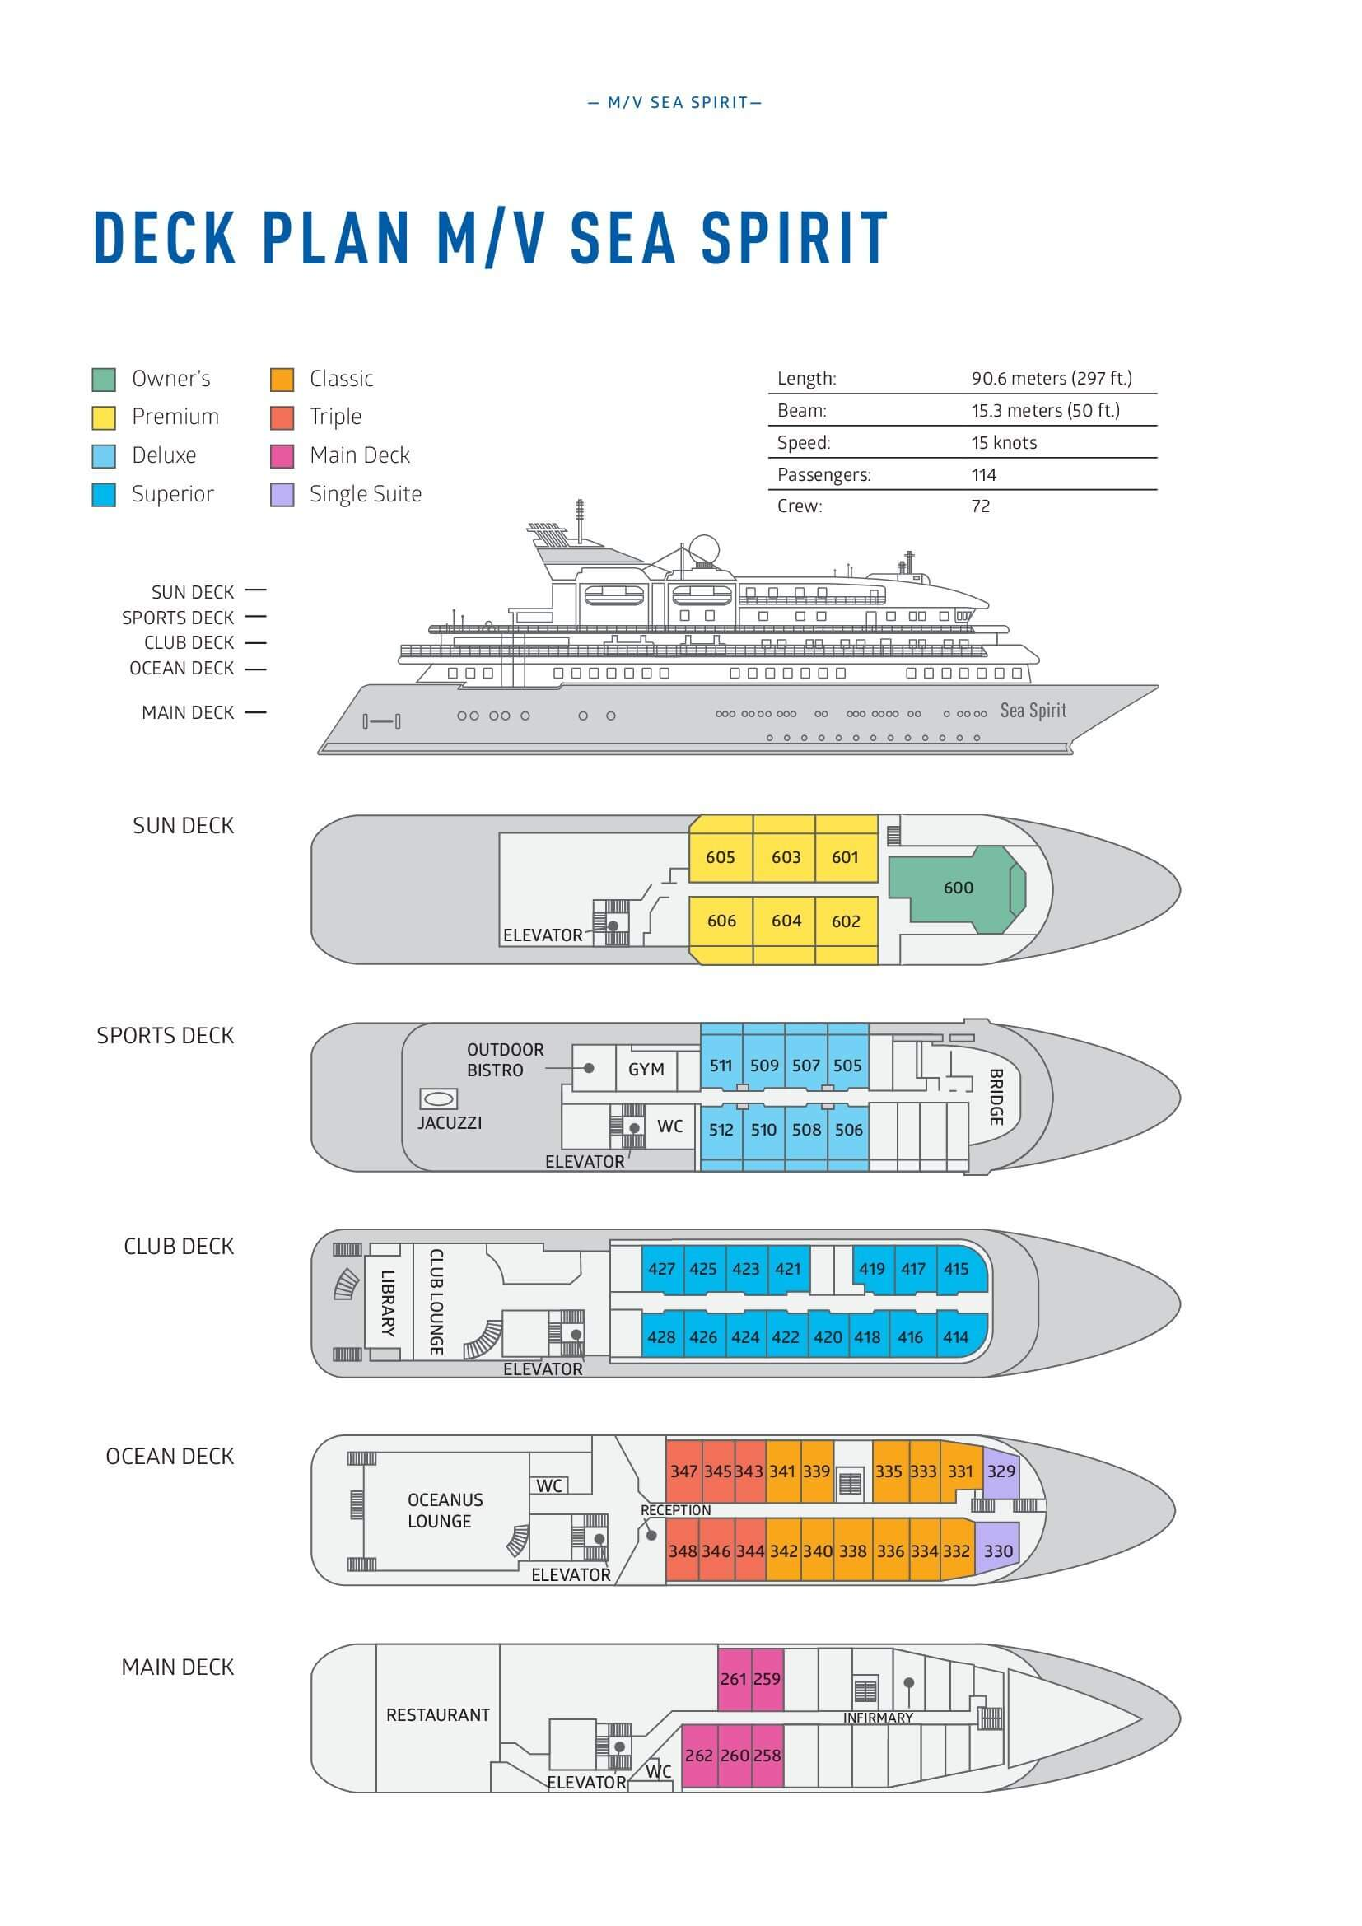

Triple Suite  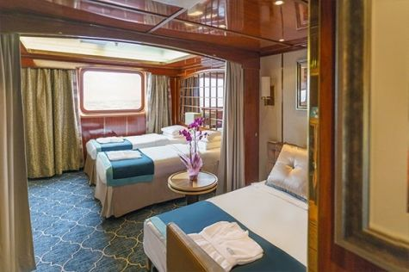  Averaging 21 square metres/226 square feet, these staterooms have two twins and a comfortable sofa bed. The twins also convert to a King, if desired. Located on Oceanus Deck, these suites have a picture window, two wardrobes and en suite facilities. Amenities include: in-room safe, refrigerator, satellite telephone access, TV/DVD, individual temperature control, and hair dryer. | Main Deck Suite  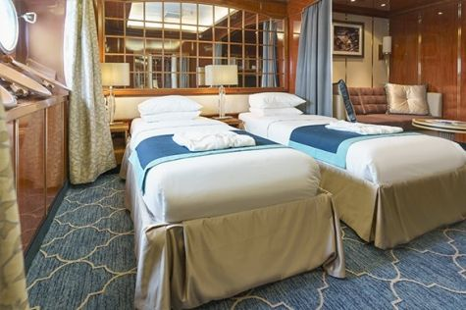  Averaging 23 square metres/248 square feet, Main Deck cabins are equipped with either two twins or a King Size bed. They are located on the Main Deck with a minimum of two portholes for exterior views. Amenities include: en suite facilities, in-room safe, refrigerator, satellite telephone access, TV/DVD individual temperature control and hair dryer.
Single Suite  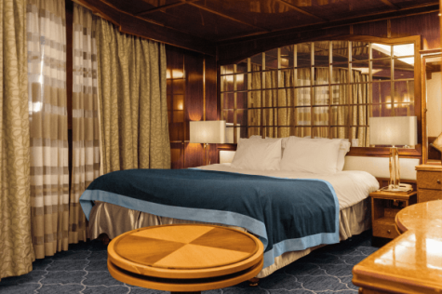  Averaging 21 square meters/226 square feet, these cabins are located on the Oceanus Deck. They feature a picture window (it may be covered during rough sea crossings), two wardrobes, and a King Size bed. Amenities include: en suite facilities, in-room safe, refrigerator, satellite telephone access, TV/VCR, individual temperature control, and hair dryer. | Classic Suite  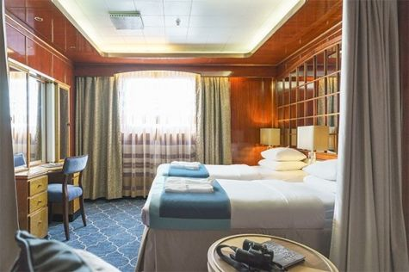  Averaging 21 square metres/226 square feet, these cabins are located on the Oceanus Deck. They feature a picture window, two wardrobes and a choice of either two twin beds or a King Size bed. Amenities include: en suite facilities, in-room safe, refrigerator, satellite telephone access, TV/DVD, individual temperature control and hair dryer.
Superior Suite  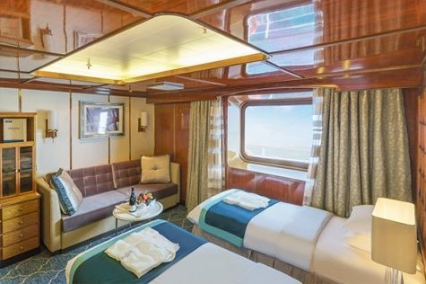  Superior Suites are located on the Club Deck. Averaging 20 square metres/ 215 square feet, these cabins feature two twin beds or a King Size bed. The picture window overlooks an outside walkway on the Club Deck. Amenities include: en suite facilities, walk-in closet or wardrobe, in-room safe, refrigerator, satellite telephone access, TV/DVD, individual temperature control, hair dryer. | Deluxe Suite  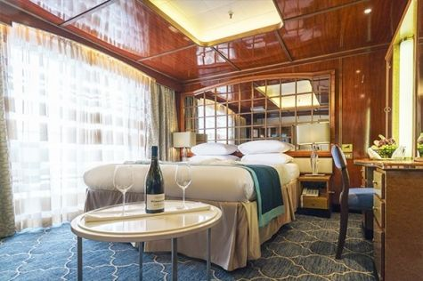  The Deluxe Suites with balconies are located on the Sports Deck. Averaging 24 square metres/ 258 square feet means plenty of room. Choose from either two twin beds or a King Size bed. A sliding glass door leads to a private balcony. These suites feature a walk-in closet or wardrobe. Amenities include en suite facilities, in-room safe, refrigerator, satellite telephone access, TV/DVD, individual temperature control, and a hair dryer.
Premium Suite  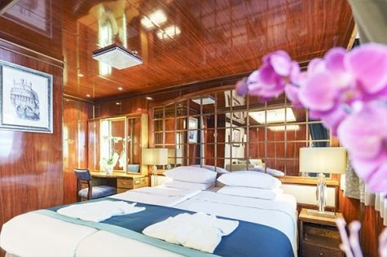  The Premium Suites are located on the Sun Deck. Averaging a generous 30 square metres/ 323 square feet, with two twin beds or a King Size bed. Access the private balcony by a sliding glass door. Amenities include: en suite facilities, lounge area, in-room safe, refrigerator, satellite telephone access, TV/DVD, individual temperature control, and hair dryer. | Owners Suite  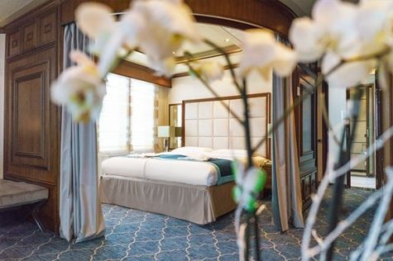  Super-spacious (63 square metres/ 678 square feet) elegant suite on the Sun Deck. Designed for entertaining, the Owner's Suite has a separate living room with game and meeting area. A BOSE stereo system provides background music, or watch videos on the HD plasma TV. Sliding glass doors lead to a private deck. Refresh in the jetted bathtub in en suite facilities. Slumber in the King Size bed. A sofa bed can accommodate a third person.

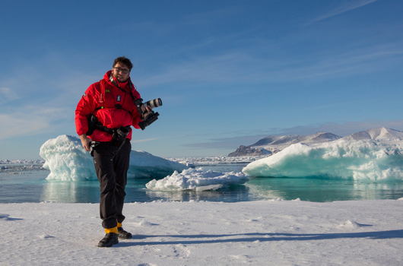 | Photography  What to expect on your photo tour  A polar cruise designed for photographers of all skill levels is a perfect way to experience the beauty and grandeur of the polar regions while also improving your photography skills.  - Watch breathtaking scenery and mesmerizing landscapes in one of the most remote places on Earth  - See the contrast of unique locations and their iconic wildlife  - Join our onboard photo workshops and get guidance from professional photographers  - Learn about the history and most significant spots in the area, and capture polar exploration history on your camera  - See an abundance of wildlife  - Discover the best wildlife viewing and photo ops with your expedition team and our onboard naturalists  - Scout the best locations on foot, on Zodiac excursions or while kayaking  - Our professional expedition team and experienced captain will maneuver and bring you safely to the places with the best photo ops

Rates Include  Roundtrip Santiago de Chile - Stanley flights on embarkation and disembarkation days;  Airport tax in Stanley airport;  Group transfer to the ship for embarkation;  Shipboard accommodation;  Wi-Fi on board;  All meals on board throughout the voyage;  Tea and coffee station 24 hours daily;  All scheduled landings/excursions (subject to weather and ice conditions);  Leadership throughout the voyage by our experienced Expedition Leader and Expedition Team;  Branded Poseidon Expeditions parka;  Rubber boots for shore landings for the time of the cruise;  IAATO fees and governmental taxes.  Welcome and Farewell cocktails;  All port fees;  Group transfer to airport after disembarkation;  Digital Voyage Log.  Pre-departure materials. | Rates Do Not Include  Airfare;  1 pre-voyage hotel night on Day 0 in Santiago de Chile;  Visa and passport fees (if applicable);  Luggage and trip cancellation insurance;  Soft drinks and alcoholic beverages other than those for special events and celebrations;  Personal expenses such as laundry and telephone calls;  Fuel surcharge may be applied for all bookings;  Mandatory Emergency Evacuation Insurance to a minimum benefit of US$ 200,000 per person;  Staff gratuities;  The cost of any applicable medical tests (such as COVID-19) or vaccinations required either by a national government or Poseidon Expeditions before, during or after the cruise  Pre- or post-cruise travel expenses.
Itinerary, landings and all other activities during the cruise depend strongly on ice and weather conditions and are subject to the decisions of the Expedition Leader and the Captain of the vessel. Encounters with any mentioned wildlife cannot be guaranteed.

