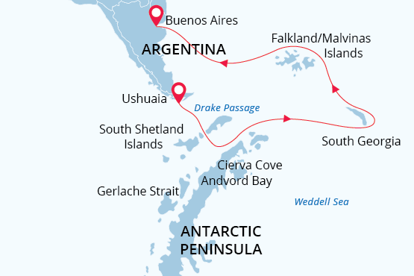

Falklands, South Georgia & Antarctica
Antarctic Wildlife Adventure
27 Feb - 21 Mar 2026
23 days
Embarkation: Ushuaia (Argentina)
Disembarkation: Buenos Aires (Argentina)
M/v Sea Spirit
Activities:

Itinerary
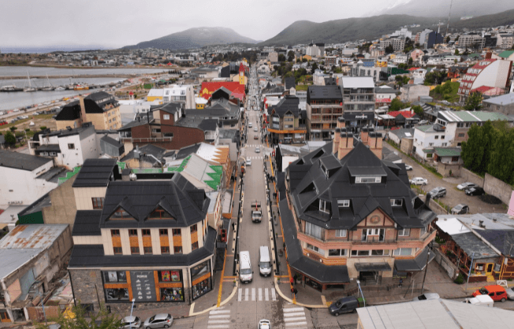Day 1 (Feb 27): Arrival in Ushuaia, Argentina (hotel night)
Welcome to Ushuaia, the world’s southernmost city and starting point of our Antarctic expedition! Upon your arrival at the airport, you will be greeted by our staff and transferred to a quality hotel, which has been arranged by us and is included in the price of the itinerary. For the rest of the day, you are free to explore this vibrant port city and adventure hub.
For an introduction to local history and wildlife, the interesting Museo del Fin del Mundo is worth a visit. If you have time to spare, a variety of nature activities can be arranged to suit all interests and fitness levels, from hiking in nearby Tierra del Fuego National Park to wildlife viewing in the Beagle Channel. For dinner, Ushuaia offers a wide range of restaurants featuring Patagonian lamb and delectable Fuegian seafood.
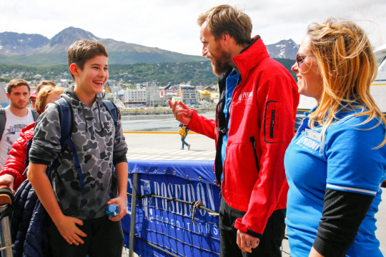Day 2 (Feb 28): Welcome Aboard!
After breakfast at your hotel, the morning is yours to enjoy Ushuaia. Explore the delightful waterfront and savor views of the snowcapped Martial Range, the southernmost peaks of the Andes. Take advantage of shopping for souvenirs or some last-minute necessities such as cold-weather gear. Just remember, you will soon receive your very own parka to keep and waterproof boots to borrow on board the ship. For lunch, the many cafés, parrillas and gelato shops on Avenida San Martín will be sure to satisfy any appetite.
In the afternoon, you will be transferred to the pier where we will warmly welcome you aboard the deluxe expedition vessel M/V Sea Spirit. Get settled in your spacious suite and explore the ship that will be your comfortable home during the extraordinary adventure to come. After getting underway, a full schedule of events kicks off with informative briefings and introductions from your expedition staff. After the first of many delicious dinners on board, step out onto the open decks to admire the scenery and gorgeous evening light as we pass through the Beagle Channel.
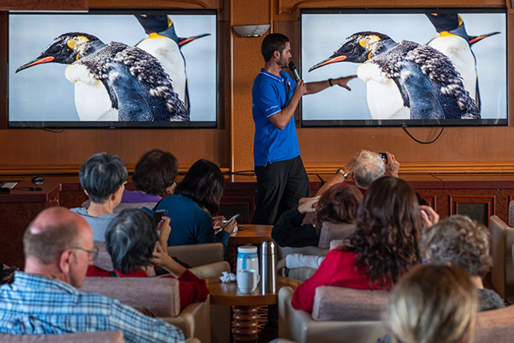Day 3-4 (March 1-2): Drake Passage
After passing the islands of Tierra del Fuego, we turn south to begin our crossing of the Drake Passage. The majestic wandering albatross and other graceful subantarctic seabirds are common in these waters and can readily be viewed from panoramic open decks and balconies. We also cross the Antarctic Convergence, the biological boundary of the Southern Ocean. The ship’s stabilizing fins provide comfort in the event of rough seas. We hope to arrive in the South Shetland Islands on the evening of our second day at sea.
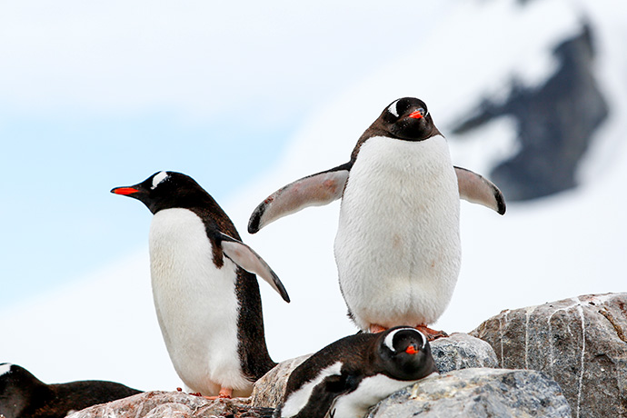Day 5-8 (March 3-6): South Shetland Islands and Antarctic Peninsula
Within the next days, we explore the highlights of the South Shetland Islands and the Antarctic Peninsula. This region contains some of the world’s most impressive scenery and the best wildlife viewing in Antarctica. Sheltered bays and channels sparkle with ice and reflect towering mountain peaks coated in permanent snow and immense glaciers. Icebergs of every size and description complete an image of incomparable beauty. Waters rich with krill are home to huge numbers of marine mammals and seabirds. The whole area is alive with penguins foraging at sea and forming large rookeries at special places on land. Here we also find Antarctic research bases of various nationalities, some with gift shops and post offices.
The South Shetland Islands are the northernmost islands in Antarctica and will likely be our first sight of land. This wildly beautiful island chain contains many landing sites with historical significance and abundant wildlife. Among them is Elephant Island, where men from Shackleton’s famous Endurance expedition spent the winter of 1916. We will also explore the supremely picturesque Gerlache Strait area of the Antarctic Peninsula, a pristine wilderness of spectacular white landscapes, colossal icebergs, obliging marine mammals and bustling penguin colonies. Here we have a chance to land on the continent of Antarctica.
Throughout this area, we find large colonies of gentoo, chinstrap and Adélie penguins, sometimes side by side. This a great time for close encounters with inquisitive penguin chicks, who are now gaining independence as they fledge. This is also the peak of the whale-watching season. Having gorged themselves on krill all summer, humpback and minke whales become more playful and obliging to Zodiacs and kayakers. Crabeater and Weddell seals are joined by Antarctic fur seals and southern elephant seals. The skies are full of newly fledged seabirds.
Antarctica is a true wilderness with unpredictable weather and ever-changing ice conditions, which will dictate our route and exploration opportunities. With more than 14 hours of daylight per day, we seize every chance to experience excellent wildlife viewing and amazing scenery via Zodiac cruises and shore excursions.
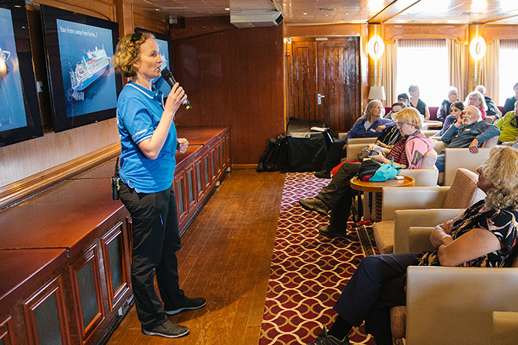Day 9-10 (March 7-8): Scotia Sea
We now proceed northeast through the wildlife-rich waters of the Scotia Sea. We keep a lookout for abundant humpback and fin whales along the way. Briefings, bio-security procedures and presentations by our lecture staff prepare you for our arrival in South Georgia.
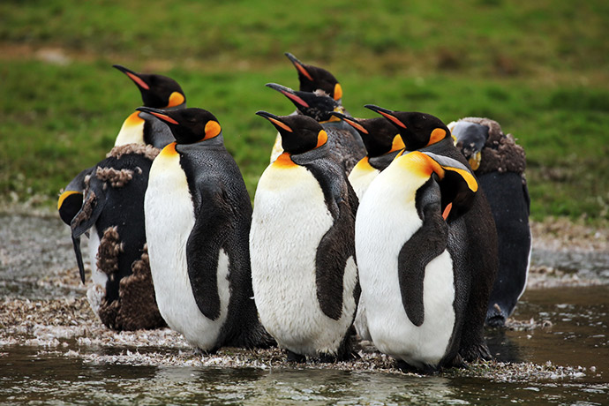Day 11-14 (March 9 -12): South Georgia Island
The next five days will be devoted to the exploration of the unique and spectacular wilderness of South Georgia, home to some of the greatest concentrations of wildlife on the planet. This isolated subantarctic island is said to host upwards of 100 million seabirds, including numerous species of albatross, penguins, prions, petrels, shags, skuas, gulls and terns. Among these is one of the largest flying birds in the world—the wandering albatross. Here you have a rare opportunity to witness part of their remarkable life cycle. While most seabird chicks are already fledging, wandering albatross chicks are only now hatching in grassy nests overlooking the wild Southern Ocean.
On South Georgia’s legendary beaches, king penguins are gathered in huge colonies that stretch from sandy shorelines to the foothills of glaciated mountains. Also at this time, hundreds of thousands of macaroni penguin chicks are getting ready to head out to sea. Rare birds such as the endemic South Georgia pipit and yellow-billed pintail round out the list of 78 bird species found across the territory. The successfully completed rat eradication program has made this wilderness even more pristine and rich with birdlife.
South Georgia is also home to staggering numbers of elephant seals and fur seals. At this time, thousands of fat elephant seal pups are lounging around on shore while mobs of rambunctious fur seal pups take to the water. Once hunted nearly to extinction, large whales have returned to the bountiful seas surrounding South Georgia. With the whalers long gone, the historical whaling station of Grytviken is now home to the excellent South Georgia Museum. Here you will also find the grave of Sir Ernest Shackleton, heroic polar explorer and leader of the Endurance expedition.
In this rugged yet accessible environment, superb wildlife viewing is best complemented by active adventure. There are many opportunities for guided treks through this raw and untamed wilderness, including the legendary Shackleton Walk. For sea kayakers, the wildlife-rich waters of South Georgia offer the chance to paddle with hordes of seals and penguins in some of the world’s most scenic waterways.
This is expedition cruising at its most authentic. Our precise route and exploration opportunities are dependent on weather in this wild and remote corner of the world. Our experienced captain and expedition leader will continually adjust plans to take maximum advantage of the conditions and circumstances at hand. You can be sure that we will take every safe opportunity to go ashore in this challenging environment.
Day 15-16 (March 13-14): Southern Ocean
We sail west toward the Falkland Islands. Presentations and workshops by our expert staff, as well as our range of onboard recreation facilities, ensure that this day at sea is not idly spent. Pelagic seabirds are our constant companions as we keep a vigilant watch for dolphins and whales in these productive waters.
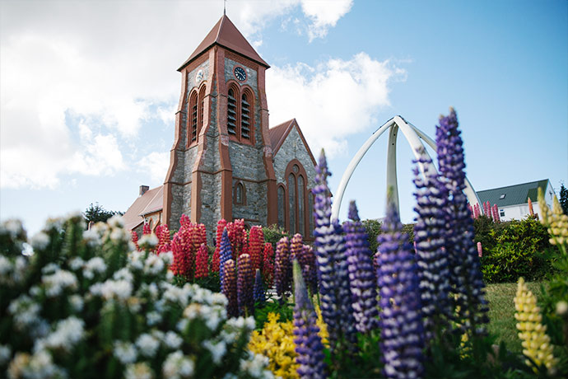Day 17-18 (March 15-16): The Falkland Islands
On these days we intend to come alongside the wharf at Stanley, the historic capital of the Falkland Islands. Attractions within pleasant walking distance along the waterfront promenade include the Falkland Islands Museum, the governor’s house, various war memorials, quality gift shops and charming pubs. Christ Church Cathedral features an impressive whalebone arch and dramatic views of shipwrecks in the harbor.
We also plan to offer an excursion to Gypsy Cove, a national nature reserve where white sand beaches are frequented by numerous bird species, including the endemic Falklands flightless steamer duck. Here you can also see Magellanic penguins, whose chicks have fledged and are making a tentative start to their lives at sea. At this time, you may even find groups of sea lions hauled out on shore.
We continue our exploration of the Falklands in the isolated outlying islands. These bleakly beautiful isles are havens for wildlife. Large colonies of seabirds, perched on windy bluffs overlooking azure seas, are easily accessible by hiking over lush meadows. At this time, black-browed albatross soar down from above while feisty rockhopper penguins leap up surf-battered cliffs from below to feed their large chicks amongst the tussocks.
On nearby beaches, gentoo penguin chicks are starting to fledge while adult king penguins and chicks of all ages are getting ready to brave the austral winter. Just offshore, you may see Peale’s dolphins and even killer whales patrolling the coasts. A wide range of land birds, including the endemic Cobb’s wren and inquisitive striated caracara, contribute to an abundance of wildlife that will leave nature lovers breathless.
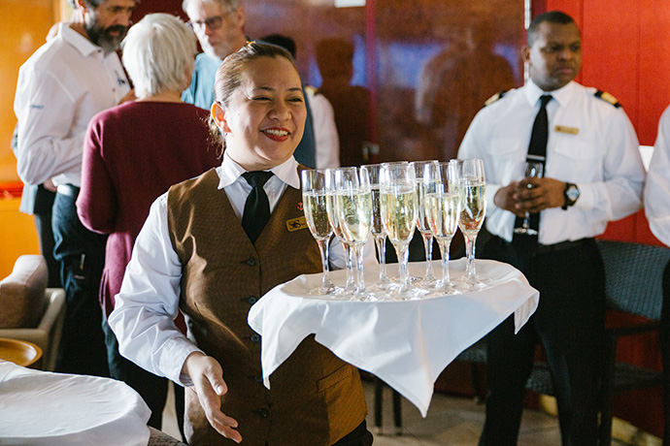Day 19-22 (March 17-20): South Atlantic Ocean
The ocean breezes gradually get warmer as we sail north through the South Atlantic Ocean. As we enter deeper waters, we are on constant lookout for killer whales, blue whales, sei whales and southern right whales. This is also the time for festivities such as the Captain’s Farewell Cocktail and the end-of-voyage slideshow.
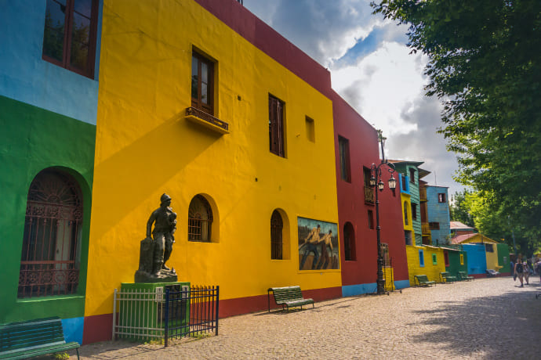Day 23 (March 21): Disembarkation in Buenos Aires (Argentina)
Right after the disembarkation, we provide a group transfer to Ezeiza (EZE) - International Airport or central location in Buenos Aires. As you look back on your wonderful experience, you may already be looking forward to your next polar adventure!
Note: we recommend to schedule your return flight from Buenos Aires (EZE) with a departure time that is not earlier than 7pm.

M/v Sea Spirit
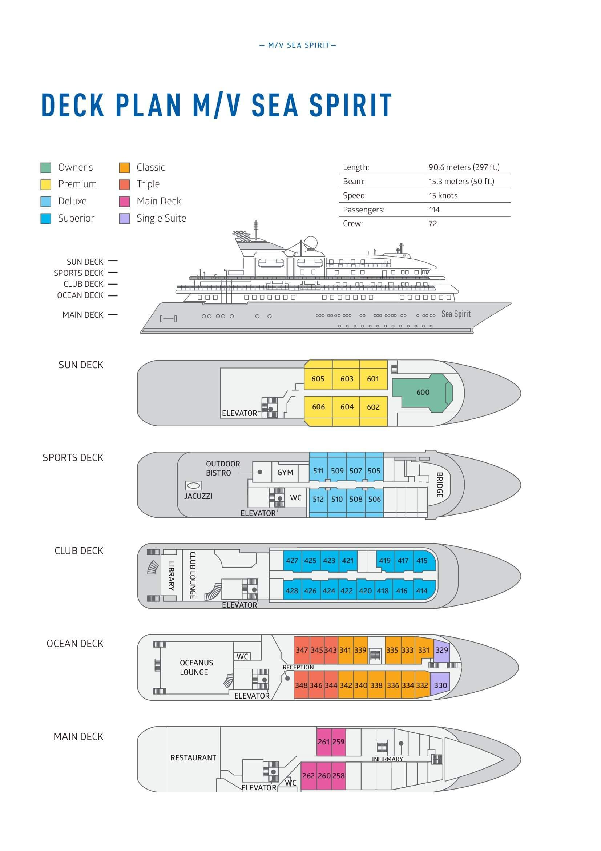

Triple Suite  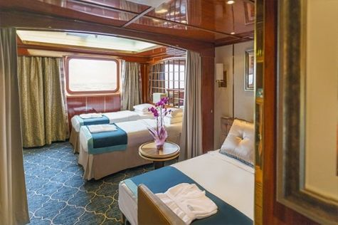  Averaging 21 square metres/226 square feet, these staterooms have two twins and a comfortable sofa bed. The twins also convert to a King, if desired. Located on Oceanus Deck, these suites have a picture window, two wardrobes and en suite facilities. Amenities include: in-room safe, refrigerator, satellite telephone access, TV/DVD, individual temperature control, and hair dryer. | Main Deck Suite  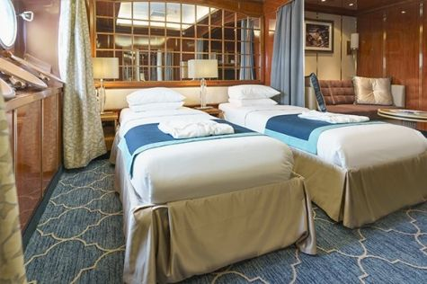  Averaging 23 square metres/248 square feet, Main Deck cabins are equipped with either two twins or a King Size bed. They are located on the Main Deck with a minimum of two portholes for exterior views. Amenities include: en suite facilities, in-room safe, refrigerator, satellite telephone access, TV/DVD individual temperature control and hair dryer.
Single Suite  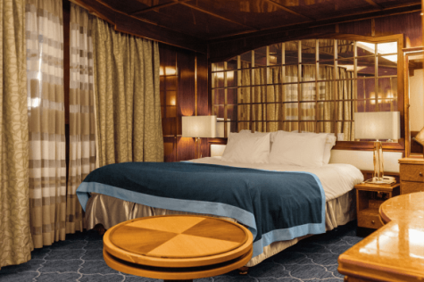  Averaging 21 square meters/226 square feet, these cabins are located on the Oceanus Deck. They feature a picture window (it may be covered during rough sea crossings), two wardrobes, and a King Size bed. Amenities include: en suite facilities, in-room safe, refrigerator, satellite telephone access, TV/VCR, individual temperature control, and hair dryer. | Classic Suite  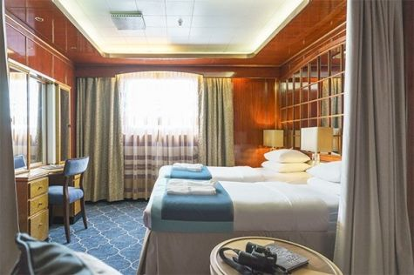  Averaging 21 square metres/226 square feet, these cabins are located on the Oceanus Deck. They feature a picture window, two wardrobes and a choice of either two twin beds or a King Size bed. Amenities include: en suite facilities, in-room safe, refrigerator, satellite telephone access, TV/DVD, individual temperature control and hair dryer.
Superior Suite  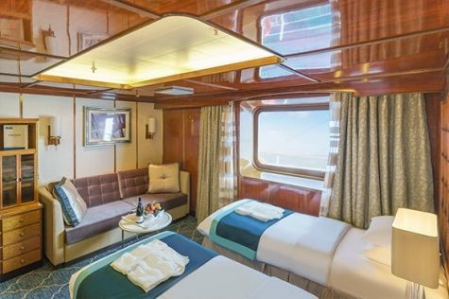  Superior Suites are located on the Club Deck. Averaging 20 square metres/ 215 square feet, these cabins feature two twin beds or a King Size bed. The picture window overlooks an outside walkway on the Club Deck. Amenities include: en suite facilities, walk-in closet or wardrobe, in-room safe, refrigerator, satellite telephone access, TV/DVD, individual temperature control, hair dryer. | Deluxe Suite  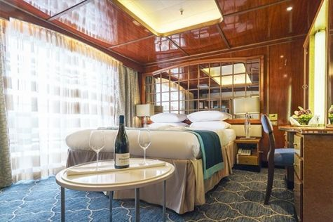  The Deluxe Suites with balconies are located on the Sports Deck. Averaging 24 square metres/ 258 square feet means plenty of room. Choose from either two twin beds or a King Size bed. A sliding glass door leads to a private balcony. These suites feature a walk-in closet or wardrobe. Amenities include en suite facilities, in-room safe, refrigerator, satellite telephone access, TV/DVD, individual temperature control, and a hair dryer.
Premium Suite  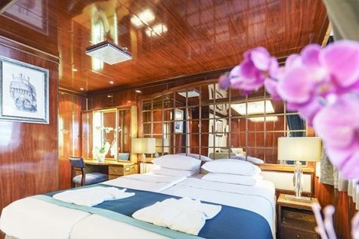  The Premium Suites are located on the Sun Deck. Averaging a generous 30 square metres/ 323 square feet, with two twin beds or a King Size bed. Access the private balcony by a sliding glass door. Amenities include: en suite facilities, lounge area, in-room safe, refrigerator, satellite telephone access, TV/DVD, individual temperature control, and hair dryer. | Owners Suite  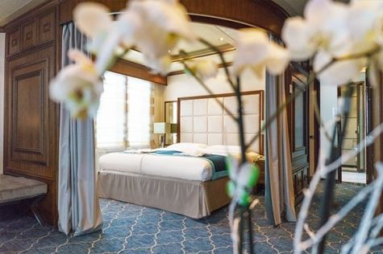  Super-spacious (63 square metres/ 678 square feet) elegant suite on the Sun Deck. Designed for entertaining, the Owner's Suite has a separate living room with game and meeting area. A BOSE stereo system provides background music, or watch videos on the HD plasma TV. Sliding glass doors lead to a private deck. Refresh in the jetted bathtub in en suite facilities. Slumber in the King Size bed. A sofa bed can accommodate a third person.

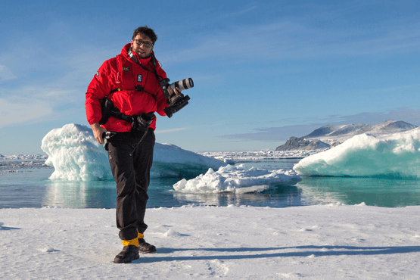 | Photography  Free option  The Polar Regions are perhaps the most photogenic on earth, with countless beautiful scenes presenting themselves every day. Endless expanses of ice, beaches crowded with seals or penguins, sunsets over unbroken horizons, starlit skies, and even the majestic northern lights – they all present fantastic photographic opportunities – and in order to make sure that you come home with some spectacular images we offer you the chance to learn and practice your photography alongside an experienced professional.  Our expert Photographer will be on hand to answer your questions and give advice, both in the form of on-board lectures and workshops on shore. Explore the key elements of photography in a fun and relaxed setting, with plenty of opportunities for questions and feedback. Learn how to see light in a new way and experiment with the techniques of composition and framing.
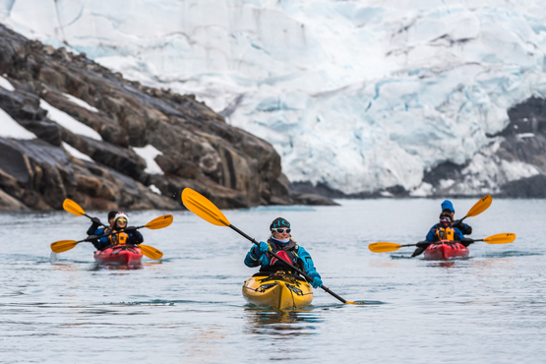 | Sea Kayaking  Kayaking fee $995 - €870 - A$1500 - £800  Antarctica is a paddlers’ paradise. The White Continent boasts some of the world’s most impressive landscapes and is home to incredible marine wildlife. Sea Kayak Club members will have the opportunity to paddle through tranquil waters filled with glittering icebergs and porpoising penguins while surrounded by magnificent glaciers and mountains.  The protected and picturesque waters of the Antarctic Peninsula offer the best sea kayaking opportunities in Antarctica. Sea Kayak Club is also offered on selected voyages to South Georgia, where members may have the rare opportunity to encounter the island’s legendary abundance of wildlife from a kayaker’s perspective, if the area’s notoriously inclement weather permits.

Rates
Triple Suite | Main Deck Suite | Single Suite | Classic Suite | Superior Suite | Deluxe Suite | Premium Suite | Owners Suite
US$ 16 695 | US$ 22 095 | US$ 33 195 | US$ 23 695 | US$ 24 095 | US$ 26 795 | US$ 28 895 | US$ 36 495
US$ 14 191 | US$ 18 781 | US$ 28 216 | US$ 20 141 | US$ 19 276 | US$ 21 436 | US$ 23 116 | US$ 29 196
* Super Early Bird discount (15% off on Triple, Main Deck, Single, and Classic Suites; 20% off on Superior, Deluxe, Premium, and Owner’s Suites) is available for new bookings confirmed by June 30, 2024.
Cruise rates are quoted per person. Sharing is available in Triple, Main Deck, Classic, and Superior Suites. If you prefer a cabin for yourself, the following categories are available with the single supplement: x1.7 for Main Deck, Classic, and Superior Suites; x2 for Deluxe, Premium, and Owner's Suite.

Rates Include  1 pre-voyage night on Day 1 in Ushuaia;  Group transfer from the airport to the hotel on the day prior to embarkation;  Group transfer to the ship for embarkation on Day 2;  Shipboard accommodation;  IAATO fees and governmental taxes.  All meals on board throughout the voyage;  Tea and coffee station 24 hours daily;  All scheduled landings/excursions (subject to weather and ice conditions);  Leadership throughout the voyage by our experienced Expedition Leader and Expedition Team;  Branded Poseidon Expeditions parka;  Rubber boots for shore landings for the time of the cruise;  Welcome and Farewell cocktails;  All port fees;  Group transfer to airport or central location right after disembarkation;  Pre-departure materials;  Digital Voyage Log;  Wi-Fi on board. | Rates Do Not Include  Airfare;  Transfers from the airport to the hotel if arriving prior to Day 1 of the program;  Visa and passport fees (if applicable);  Luggage and trip cancellation insurance;  Soft drinks and alcoholic beverages other than those for special events and celebrations;  Personal expenses such as laundry and telephone calls;  Fuel surcharge may be applied for all bookings;  Mandatory Emergency Evacuation Insurance to a minimum benefit of US$ 200,000 per person;  Staff gratuities;  Kayaking;  The cost of any applicable medical tests (such as COVID-19) or vaccinations required either by a national government or Poseidon Expeditions before, during or after the cruise;  Pre- or post-cruise travel expenses.
Itinerary, landings and all other activities during the cruise depend strongly on ice and weather conditions and are subject to the decisions of the Expedition Leader and the Captain of the vessel. Encounters with any mentioned wildlife cannot be guaranteed.

